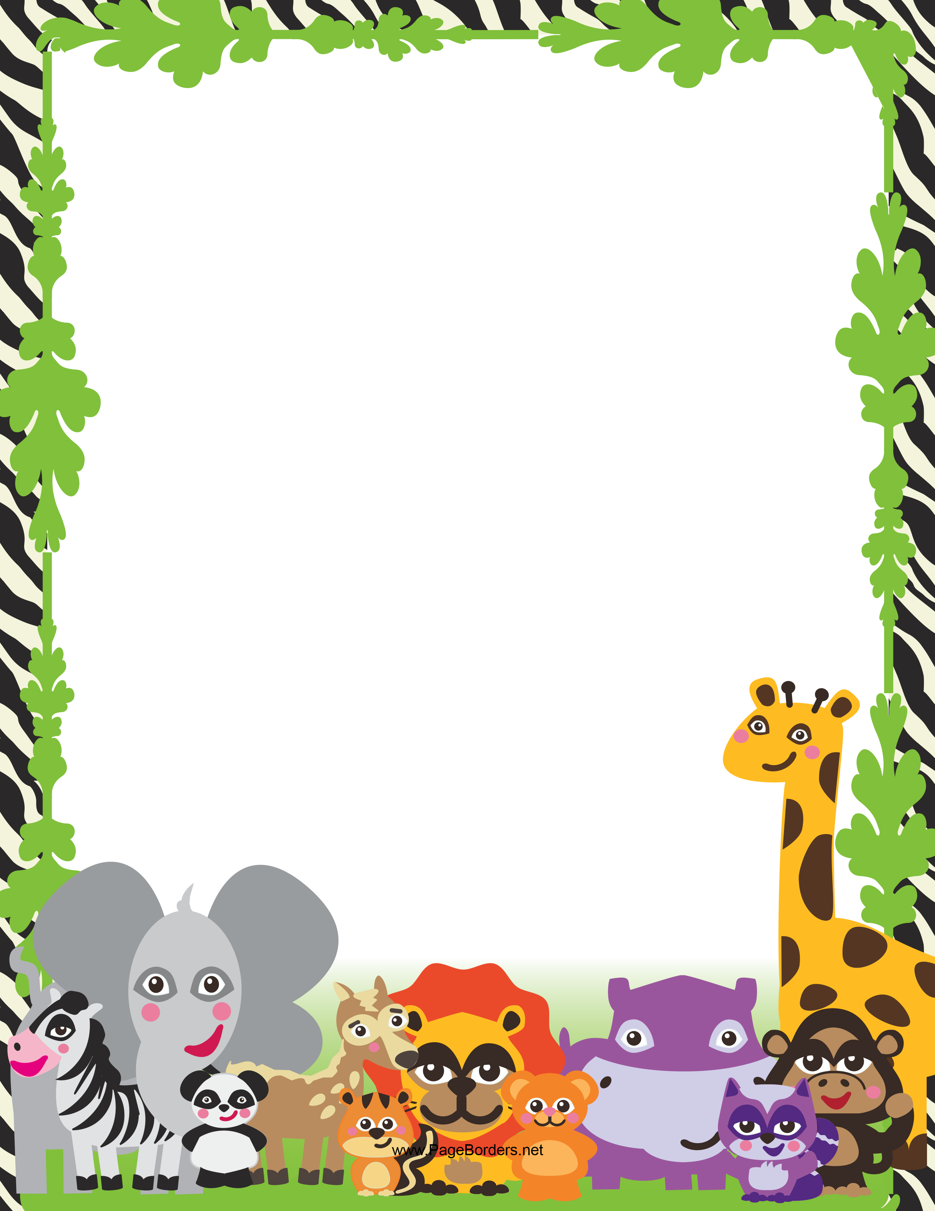

1G Weeks 9 – 10 Homework Project

This term 1G have been studying different animals and have been learning how to write information reports using the information we’ve researched.

Choose an animal that you are interested in and research it using the internet, books and/or magazines. You will need to research it’s:
- Habitat
- Diet
- Appearance
- Family & Young (babies)
- Interesting Facts

You can present your information however you choose!

I can’t wait to learn all about your chosen animal!

